**PROGRAM 10:COLLEGE DATABASE**

Consider the schema for College Database:

**STUDENT**(USN, SName, Address, Phone, Gender)

**SEMSEC**(SSID, Sem, Sec)

**CLASS**(USN, SSID)

**SUBJECT**(Subcode, Title, Sem, Credits)

**IAMARKS**(USN, Subcode, SSID, Test1, Test2, Test3, FinalIA)

Write SQL queries to

1. List all the student details studying in fourth semester ‘C’section.

2. Compute the total number of male and female students in each semester and in each section.

3. Create a view of Test1 marks of student USN ‘1BI15CS101’ in all subjects.

4. Calculate the FinalIA (average of best two test marks) and update the corresponding table for all students.

5. Categorize students based on the following criterion:

If FinalIA = 17 to 20 then CAT = ‘Outstanding’

If FinalIA = 12 to 16 then CAT = ‘Average’

If FinalIA< 12 then CAT = ‘Weak’

Give these details only for 8th semester A, B, and C section students.

drop database college;

create database college;

use college;

CREATE TABLE STUDENT (

USN VARCHAR (10) PRIMARY KEY,

SNAME VARCHAR (25),

ADDRESS VARCHAR (25),

PHONE INT ,

GENDER CHAR (1));

CREATE TABLE SEMSEC (

SSID VARCHAR (5) PRIMARY KEY,

SEM INT ,

SEC CHAR (1));

CREATE TABLE CLASS (

USN VARCHAR (10),

SSID VARCHAR (5),

PRIMARY KEY (USN, SSID),

FOREIGN KEY (USN) REFERENCES STUDENT (USN),

FOREIGN KEY (SSID) REFERENCES SEMSEC (SSID));

CREATE TABLE SUBJECT (

SUBCODE VARCHAR (8),

TITLE VARCHAR (20),

SEM INT,

CREDITS INT,

PRIMARY KEY (SUBCODE));

CREATE TABLE IAMARKS (

USN VARCHAR (10),

SUBCODE VARCHAR (8),

SSID VARCHAR (5),

TEST1 INT,

TEST2 INT,

TEST3 INT,

FINALIA INT,

PRIMARY KEY (USN, SUBCODE, SSID),

FOREIGN KEY (USN) REFERENCES STUDENT (USN),

FOREIGN KEY (SUBCODE) REFERENCES SUBJECT (SUBCODE),

FOREIGN KEY (SSID) REFERENCES SEMSEC (SSID));

INSERT INTO STUDENT VALUES ('1RN13CS020','AKSHAY','BELAGAVI', 1232654578,'M');

INSERT INTO STUDENT VALUES ('1RN13CS062','SANDHYA','BENGALURU', 1232654578,'F');

INSERT INTO STUDENT VALUES ('1RN13CS091','TEESHA','BENGALURU', 1232654578,'F');

INSERT INTO STUDENT VALUES ('1RN13CS066','SUPRIYA','MANGALURU', 1232654578,'F');

INSERT INTO STUDENT VALUES ('1RN14CS010','ABHAY','BENGALURU', 1232654578,'M');

INSERT INTO STUDENT VALUES ('1RN14CS032','BHASKAR','BENGALURU', 1232654578,'M');

INSERT INTO STUDENT VALUES ('1RN14CS025','ASMI','BENGALURU', 1232654578,'F');

INSERT INTO STUDENT VALUES ('1RN15CS011','AJAY','TUMKUR', 1232654578,'M');

INSERT INTO STUDENT VALUES ('1RN15CS029','CHITRA','DAVANGERE', 1232654578,'F');

INSERT INTO STUDENT VALUES ('1RN15CS045','JEEVA','BELLARY', 1232654578,'M');

INSERT INTO STUDENT VALUES ('1RN15CS091','SANTOSH','MANGALURU', 1232654578,'M');

INSERT INTO STUDENT VALUES ('1RN16CS045','ISMAIL','KALBURGI', 1232654578,'M');

INSERT INTO STUDENT VALUES ('1RN16CS088','SAMEERA','SHIMOGA', 1232654578,'F');

INSERT INTO STUDENT VALUES ('1RN16CS122','VINAYAKA','CHIKAMAGALUR', 1232654578,'M');

INSERT INTO SEMSEC VALUES ('CSE8A', 8,'A');

INSERT INTO SEMSEC VALUES ('CSE8B', 8,'B');

INSERT INTO SEMSEC VALUES ('CSE8C', 8,'C');

INSERT INTO SEMSEC VALUES ('CSE7A', 7,'A');

INSERT INTO SEMSEC VALUES ('CSE7B', 7,'B');

INSERT INTO SEMSEC VALUES ('CSE7C', 7,'C');

INSERT INTO SEMSEC VALUES ('CSE6A', 6,'A');

INSERT INTO SEMSEC VALUES ('CSE6B', 6,'B');

INSERT INTO SEMSEC VALUES ('CSE6C', 6,'C');

INSERT INTO SEMSEC VALUES ('CSE5A', 5,'A');

INSERT INTO SEMSEC VALUES ('CSE5B', 5,'B');

INSERT INTO SEMSEC VALUES ('CSE5C', 5,'C');

INSERT INTO SEMSEC VALUES ('CSE4A', 4,'A');

INSERT INTO SEMSEC VALUES ('CSE4B', 4,'B');

INSERT INTO SEMSEC VALUES ('CSE4C', 4,'C');

INSERT INTO SEMSEC VALUES ('CSE3A', 3,'A');

INSERT INTO SEMSEC VALUES ('CSE3B', 3,'B');

INSERT INTO SEMSEC VALUES ('CSE3C', 3,'C');

INSERT INTO SEMSEC VALUES ('CSE2A', 2,'A');

INSERT INTO SEMSEC VALUES ('CSE2B', 2,'B');

INSERT INTO SEMSEC VALUES ('CSE2C', 2,'C');

INSERT INTO SEMSEC VALUES ('CSE1A', 1,'A');

INSERT INTO SEMSEC VALUES ('CSE1B', 1,'B');

INSERT INTO SEMSEC VALUES ('CSE1C', 1,'C');

INSERT INTO CLASS VALUES ('1RN13CS020','CSE8A');

INSERT INTO CLASS VALUES ('1RN13CS062','CSE8A');

INSERT INTO CLASS VALUES ('1RN13CS066','CSE8B');

INSERT INTO CLASS VALUES ('1RN13CS091','CSE8C');

INSERT INTO CLASS VALUES ('1RN14CS010','CSE7A');

INSERT INTO CLASS VALUES ('1RN14CS025','CSE7A');

INSERT INTO CLASS VALUES ('1RN14CS032','CSE7A');

INSERT INTO CLASS VALUES ('1RN15CS011','CSE4A');

INSERT INTO CLASS VALUES ('1RN15CS029','CSE4A');

INSERT INTO SUBJECT VALUES ('10CS81','ACA', 8, 4);

INSERT INTO SUBJECT VALUES ('10CS82','SSM', 8, 4);

INSERT INTO SUBJECT VALUES ('10CS83','NM', 8, 4);

INSERT INTO SUBJECT VALUES ('10CS84','CC', 8, 4);

INSERT INTO SUBJECT VALUES ('10CS85','PW', 8, 4);

INSERT INTO SUBJECT VALUES ('10CS71','OOAD', 7, 4);

INSERT INTO SUBJECT VALUES ('10CS72','ECS', 7, 4);

INSERT INTO SUBJECT VALUES ('10CS73','PTW', 7, 4);

INSERT INTO SUBJECT VALUES ('10CS74','DWDM', 7, 4);

INSERT INTO IAMARKS (USN, SUBCODE, SSID, TEST1, TEST2, TEST3) VALUES ('1RN13CS091','10CS81','CSE8C', 15, 16, 18);

INSERT INTO IAMARKS (USN, SUBCODE, SSID, TEST1, TEST2, TEST3) VALUES ('1RN13CS091','10CS82','CSE8C', 12, 19, 14);

INSERT INTO IAMARKS (USN, SUBCODE, SSID, TEST1, TEST2, TEST3) VALUES ('1RN13CS091','10CS83','CSE8C', 19, 15, 20);

INSERT INTO IAMARKS (USN, SUBCODE, SSID, TEST1, TEST2, TEST3) VALUES ('1RN13CS091','10CS84','CSE8C', 20, 16, 19);

INSERT INTO IAMARKS (USN, SUBCODE, SSID, TEST1, TEST2, TEST3) VALUES ('1RN13CS091','10CS85','CSE8C', 15, 15, 12);

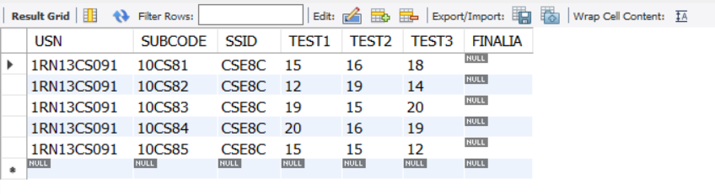select * from iamarks;

select * from subject;

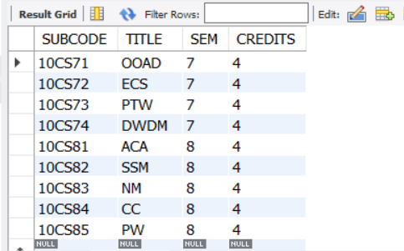

select * from student;

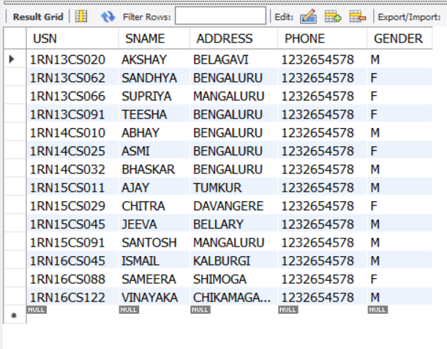

select * from class;

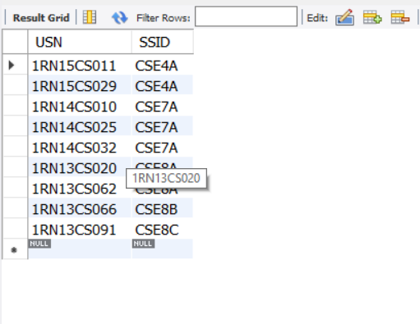

select * from semsec;

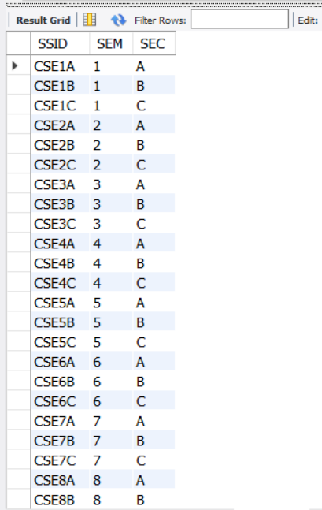



/* List all the student details studying in fourth semester ‘A’ section */

SELECT S.*, SS.SEM, SS.SEC

FROM STUDENT S, SEMSEC SS, CLASS C

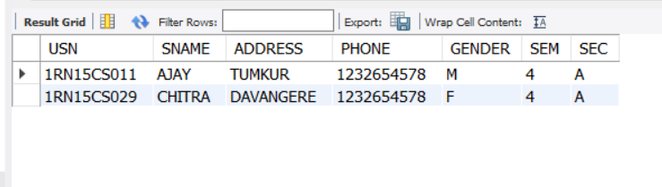WHERE S.USN = C.USN AND SS.SSID = C.SSID AND SS.SEM = 4 AND SS.SEC='A';

/* Compute the total number of male and female students in each semester and in each section */

SELECT SS.SEM, SS.SEC, S.GENDER, COUNT(S.GENDER) AS COUNT

FROM STUDENT S, SEMSEC SS, CLASS C

WHERE S.USN = C.USN AND

SS.SSID = C.SSID

GROUP BY SS.SEM, SS.SEC, S.GENDER

ORDER BY SEM;

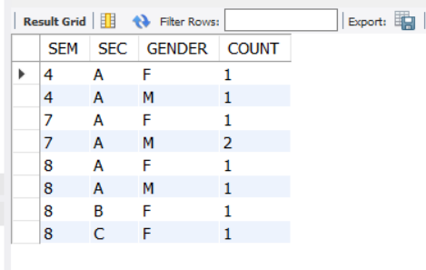

/* Create a view of Test1 marks of student USN ‘1BI15CS101’ in all subjects */

CREATE VIEW STU_TEST1_MARKS_VIEW

AS

SELECT TEST1, SUBCODE

FROM IAMARKS

WHERE USN = '1RN13CS091';

select * from STU_TEST1_MARKS_VIEW;

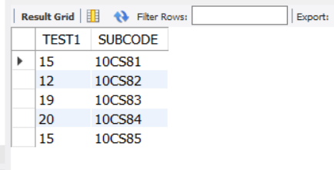

/* Categorize students based on the following criterion:

If FinalIA = 17 to 20 then CAT = ‘Outstanding’

If FinalIA = 12 to 16 then CAT = ‘Average’

If FinalIA< 12 then CAT = ‘Weak’

Give these details only for 8th semester A, B, and C section students */

update iamarks set finalia=(test1+test2+test2)/3;

SELECT S.USN,S.SNAME,S.ADDRESS,S.PHONE,S.GENDER,

(CASE

WHEN IA.FINALIA BETWEEN 17 AND 20 THEN 'OUTSTANDING'

WHEN IA.FINALIA BETWEEN 12 AND 16 THEN 'AVERAGE'

ELSE 'WEAK'

END) AS CAT

FROM STUDENT S, SEMSEC SS, IAMARKS IA, SUBJECT SUB

WHERE S.USN = IA.USN AND

SS.SSID = IA.SSID AND

SUB.SUBCODE = IA.SUBCODE AND

SUB.SEM = 8;

Commit

